Scrum - Artifacts Workbook

**Definition of Done**

|  |  |
| --- | --- |
| Definition | Done includes everything we need to do for all items of this increment release, including user acceptance testing. |
| Purpose | The definition of ‘done’ is a well-understood and clearly documented definition of items that must be established to mark a story (or iteration or project) to be complete. Getting a story to a completed state per the definition of done should be the goal of a team and should be used as the basis for planning. |

**Product Backlog**

|  |  |
| --- | --- |
| Definition | The definition of ‘done’ is a well-understood and clearly documented definition of items that must be established to mark a story (or iteration or project) to be complete. Getting a story to a completed state per the definition of done should be the goal of a team and should be used as the basis for planning. |
| Purpose | Different people in the business will ask for different “stuff.”  Not everything that is asked for has value to the business.  Some things may be valuable only to the person asking rather than to the entire business. |
| Ordering | List is worked based on what the highest priority or value is to the business. |
| Product Backlog Grooming | Contains all/any requests from the business for new items/changes to ex isting items. Ordered list of user requests/requirements |
| Large Items | Large items are called Epics. |
| PBIs | Each Entry is called Product Backlog Item. |

**Sprint Backlog**

|  |  |
| --- | --- |
| Definition | List of work to be performed during the sprint. |
| Purpose | Created for current sprint by selecting items from the product backlog during the sprint planning session. |
| Source of items | Prioritized with plan of accomplishment. |
| How are items chosen? | Chosen based on the estimated work required to complete. |
| What does value  orientation vs. results orientation mean? | Value orientation and Orientation is often a balance while delivering value to the customer is a primary goal, teams also need to ensure that they are achieving measurable results. |
| Task Board | Tasks are tracked progressively to completion. Task Board is re-evaluated every day during the daily standup. |
| Sprint Backlog Item | Interactive list of work to be performed during sprint. Used daily to identify workflow. |

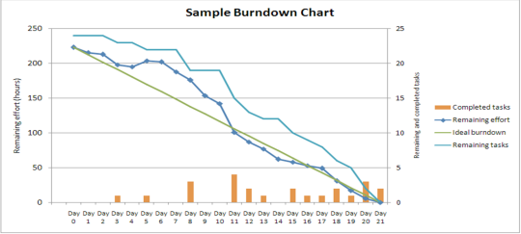**Burndown Chart**

|  |  |
| --- | --- |
| Purpose | Show remaining work in Sprint Backlog. Simple view of Sprint progress. Displayed in common work area |
| How is it updated? | Assessed daily |
| How often is  it used? | Daily |
| Significance? | It helps direct the workflow of the day. |

**User Stories**

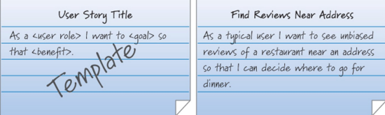

|  |  |
| --- | --- |
| Definition | Describes what the user needs to do the job function |
| Purpose | Used as the basis for defining the function of the business system |
| Format |  |
| Source |  |
| Attributes for completeness |  |

**Estimation**

|  |  |
| --- | --- |
| Story Points | Choosing enough work to fill up a full sprint:  Based on relative effort.  Show only the relative size of the item - not the time to complete.  Teams pick a simple, agreed-upon basis. |
| Planning Poker | Based on the Fibonacci Sequence:  Each numbered card represents the amount of work the team member believes this item represents.  Each development team member is issued one set of cards.  If when hands are shown, there is not a clear agreement on the amount of work involved, high and low bidders will explain why they chose that bid.  The team will re-vote until they reach a consensus. |
| Fibonacci  Sequence | The Fibonacci sequence is a type series where each number is the sum of the two that precede it. |